**Exercise 1: Configuring a Basic Spring Application**

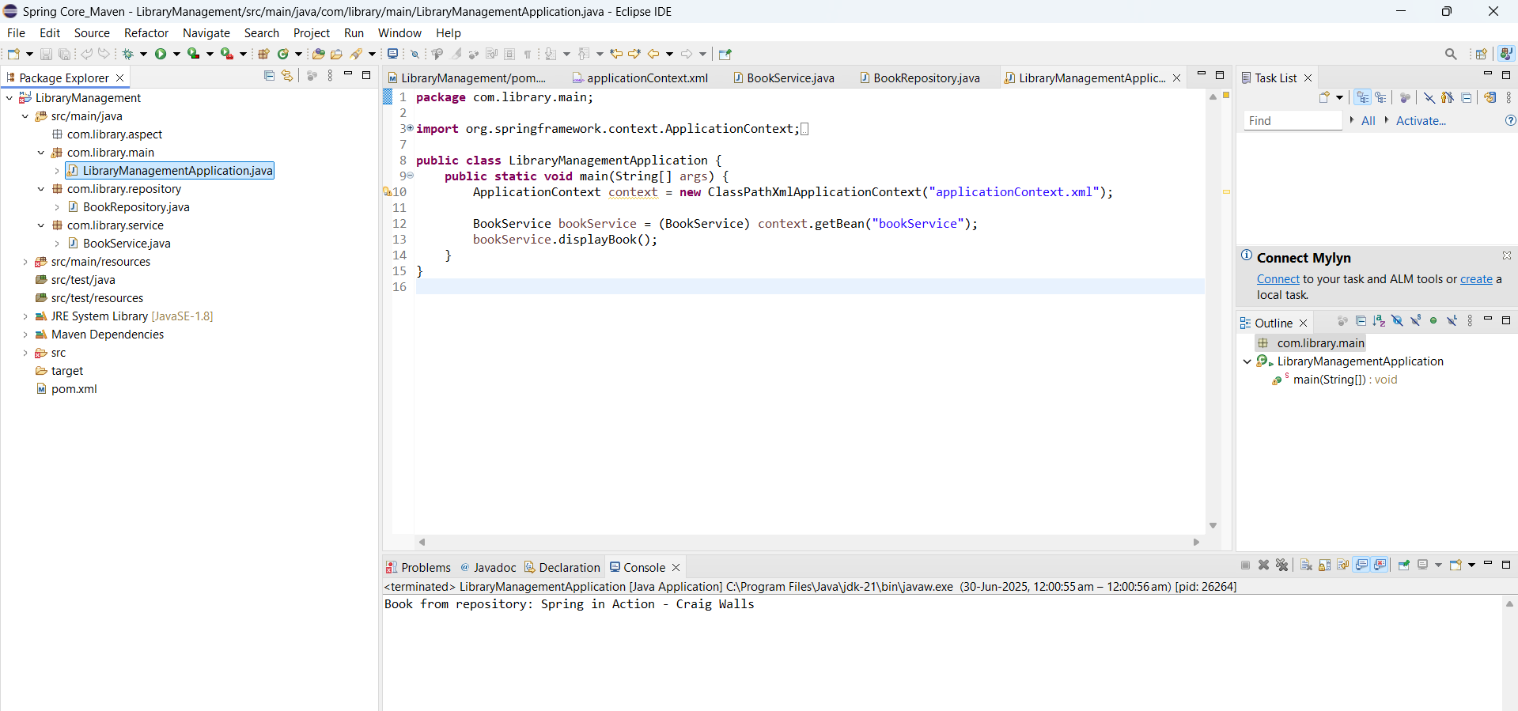

**Exercise 2: Implementing Dependency Injection**

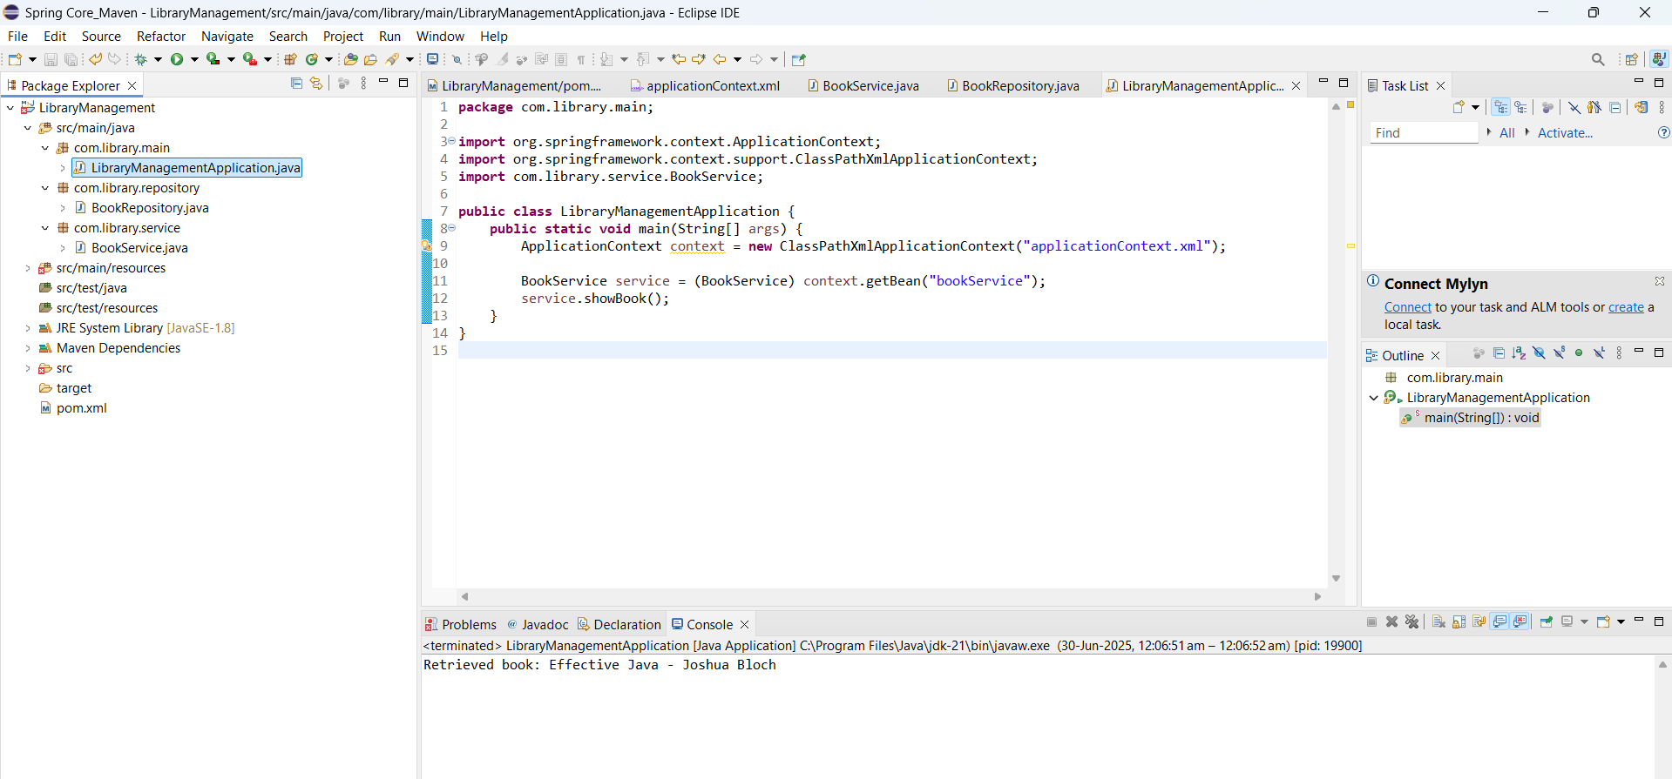

**Exercise 3: Implementing Logging with Spring AOP**

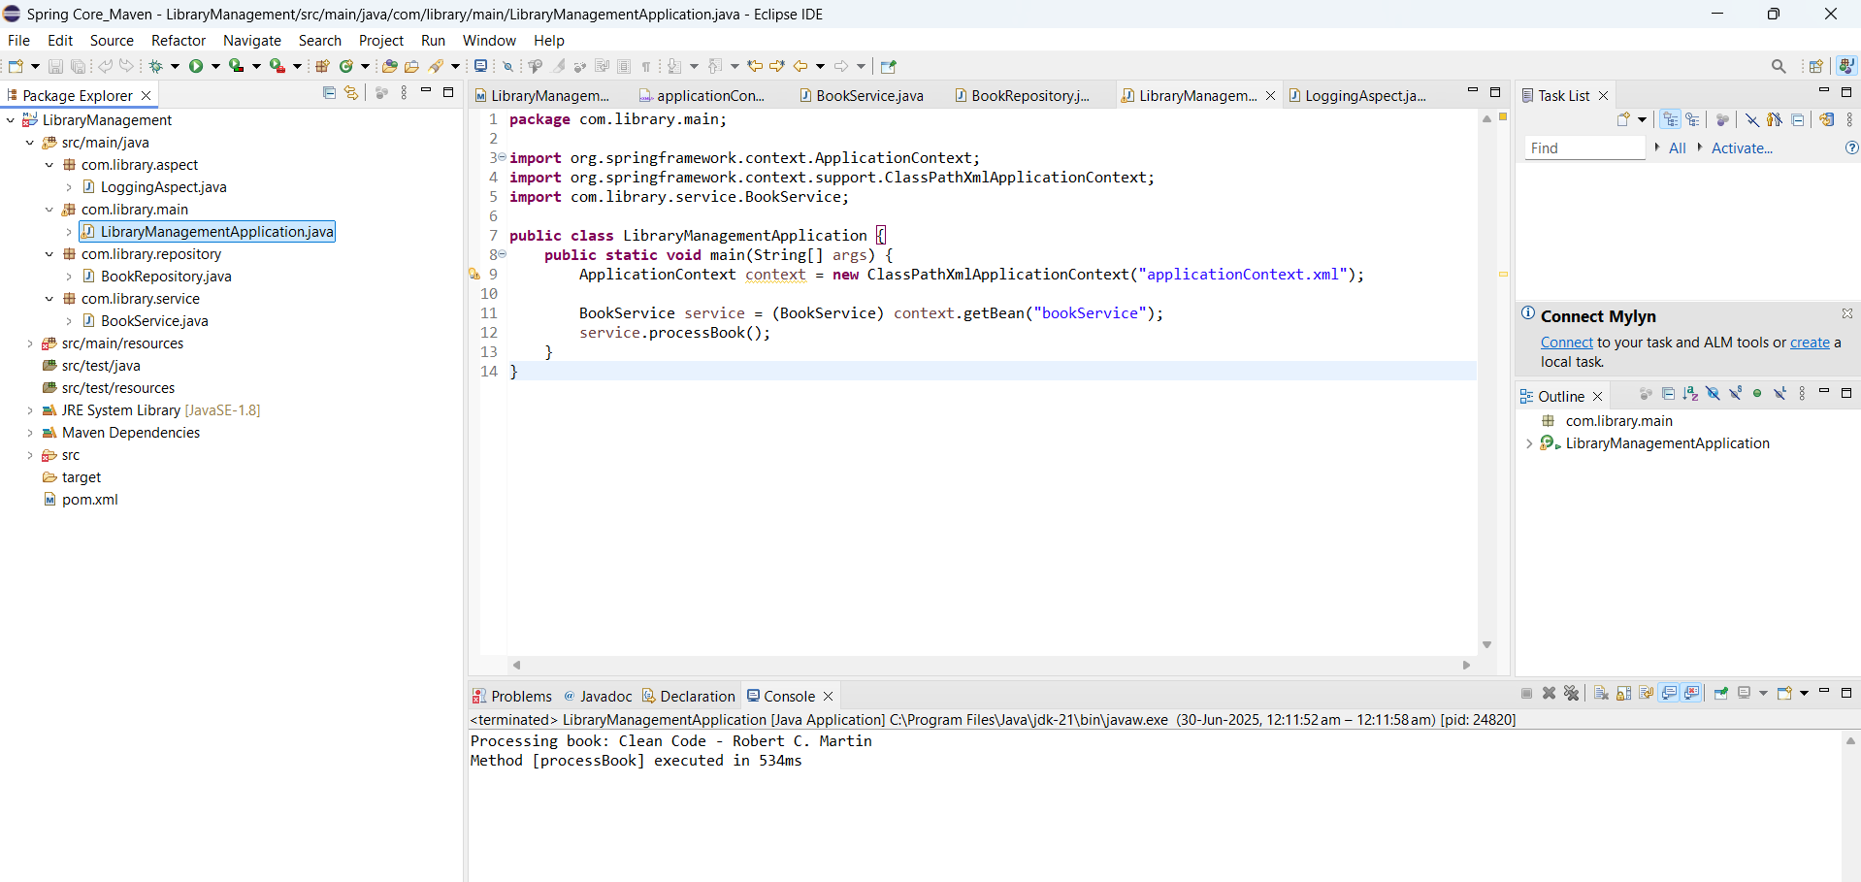

**Exercise 4: Creating and Configuring a Maven Project**

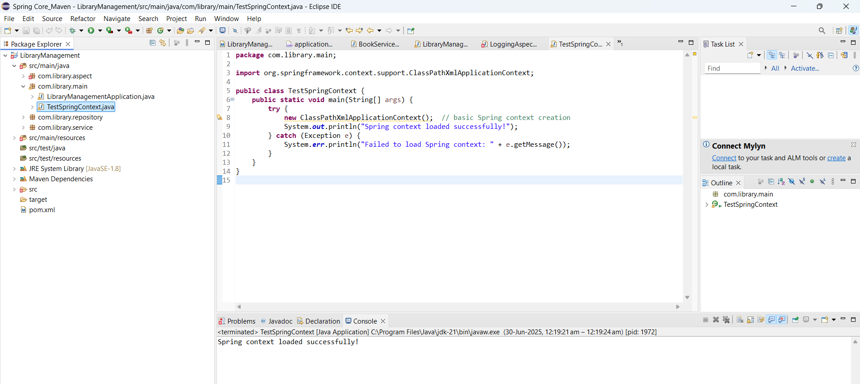

**Exercise 5: Configuring the Spring IoC Container**

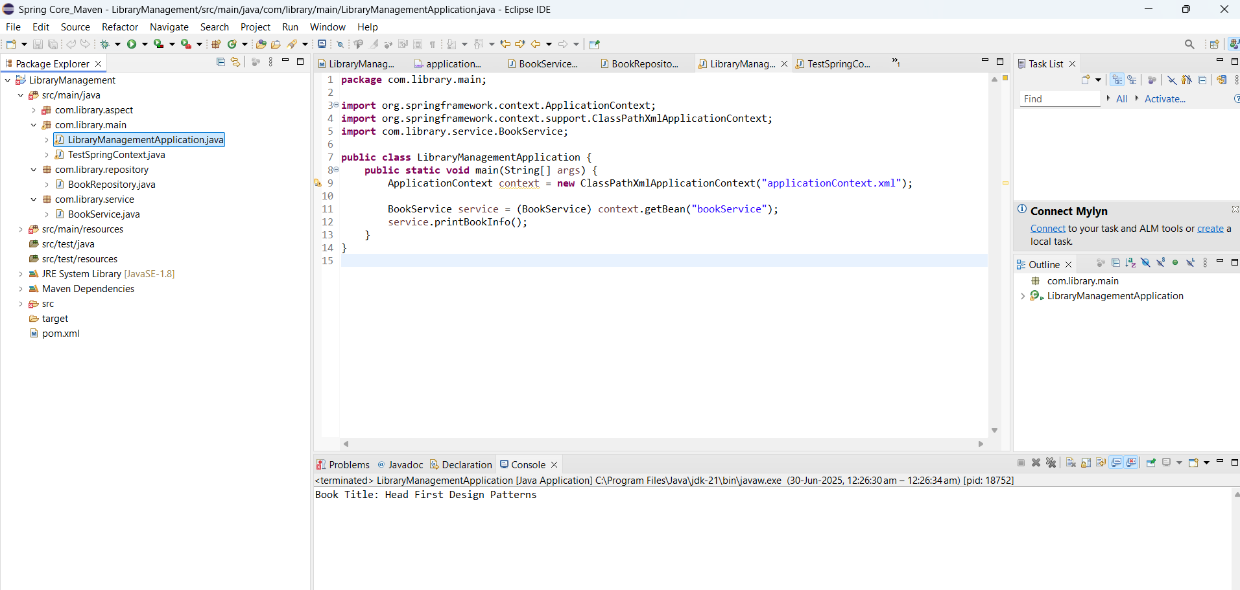

**Exercise 6: Configuring Beans with Annotations**

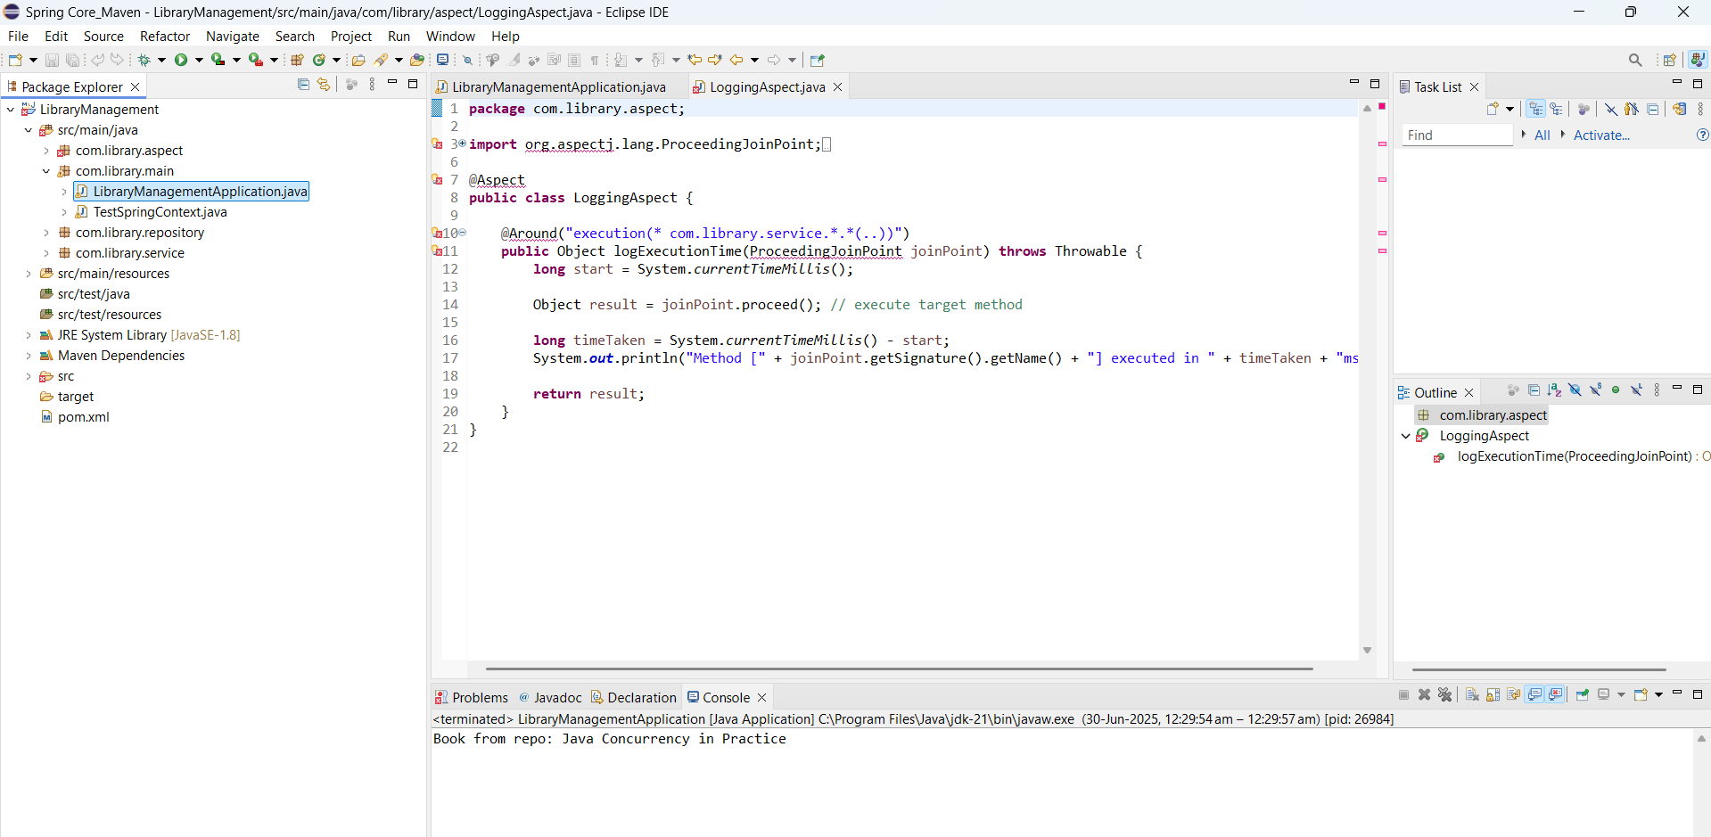

**Exercise 7: Implementing Constructor and Setter Injection**

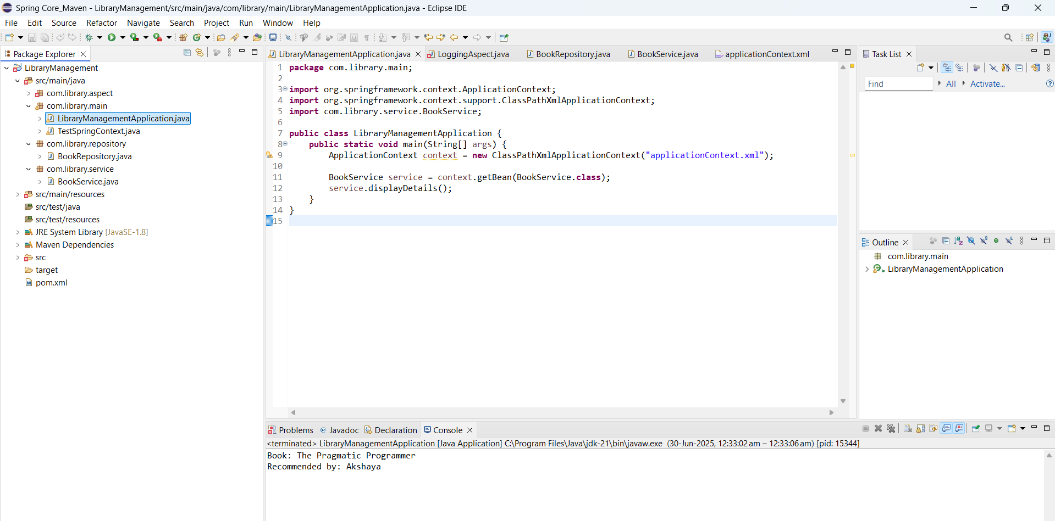

**Exercise 8: Implementing Basic AOP with Spring**

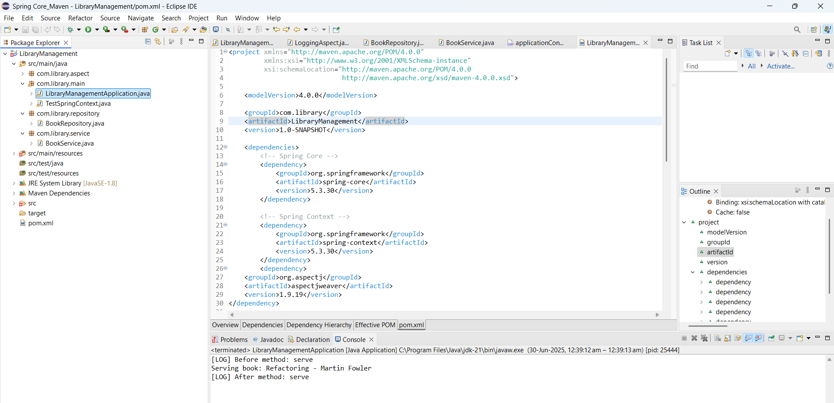

**Exercise 9: Creating a Spring Boot Application**